WT588D CHIPS & MODULES DETAILED INFORMATION
Catalog
1.FEATURES 3
2. WT588D FUNCTION DESCRIPTIONS 4
3.WT588D SELECTION 4
4.THE RELATION BETWEEN FLASH CAPACITY AND DURATION 4
5.APPLICATIONS 5
6.WT588D APPLICATION DIAGRAM 5
7.PACKAGE SKETCH 6
8.PIN DESCRIPTIONS 6
8.1. 16PIN MODULE PIN’S DESCRIPTION 6
8.2. 28PIN MODULE(V1.1) PIN’S DESCRIPTION 7
8.3. 28PIN MODULE(V1.2) PIN’S DESCRIPTION 8
8.4. LQFP32 PACKAGE PIN’S DESCRIPTION 9
8.5.DIP18 PACKAGE PIN’S DESCRIPTION 10
8.6.SSOP20 PACKAGE PIN’S DESCRIPTION 10
9.PIN’S DETAILED DESCRIPTION 11
10.ELECTRONIC PARAMETERS 11
11.ENVIRONMENTAL LIMITED PARAMETER 12
12.CONTROL MODE 12
12.1. MP3 MODE 12
12.2. KEY CONTROL MODE 12
12.2.1. EDGE RETRIGGER 13
12.2.2. EDGE NO RETRIGGER 13
12.2.3. LEVEL LOOP 13
12.2.4. LEVEL UNLOOP 13
12.2.5. LEVEL HOLD LOOP 14
12.2.6. ON/OFF 14
12.2.7.NEXT UNLOOP 14
12.2.8. PREV UNLOOP 14
12.2.9. NEXT LOOP 15
12.2.10.PREV LOOP 15
12.2.11. PAUSE 15
12.2.12. STOP 15
12.3. 3X8 MATRIX KEY CONTROL MODE 15
12.4.PARALLEL CONTRL MODE 16
12.4.1. SPEECHES AND ADDRESSES CORRESPONDANCE 16
12.4.2 CONTROL TIMING DIAGRAM 16
12.5.ONE-LINE CONTROL MODE 16
12.5.1. ASSIGNMENT OF I/O 16
12.5.2.COMMAND AND CODE 17
12.5.3.THE RELATIONSHIP BETWEEN SPEECH AND ADDRESS 17
12.5.4.CONTROL TIMING DIAGRAM 17
12.2.5. ONE LINE SERIAL CONTROL DIAGRAM SAMPLE 18
12.5.5. PROGRAM EXAMPLE 18
12.6.THREE-LINE SERIAL CONTROL MODE 18
12.6.1.ASSIGNMENT OF I/O 18
12.6.2. SPEECH AND COMMAND 19
12.6.3.THE RELATIONSHIP BETWEEN SPEECH AND ADDRESS 19
12.6.4. THREE-LINE SERIAL CONTROL I/O EXTENSION OUTPUT 19
12.6.5. THREE-LINE SERIAL CONTROL TIMING 20
12.6.6. PROGRAM EXSAMPLE 20
13. CONTROL TIMING 21
13.1.CONTROL TIMING DIAGRAM 21
13.2. ONE-LINE SERIAL CONTROL PROGRAMMING 21
13.3. ONE-LINE SERIAL CONTROL “C” PROGRAMMING LANGUAGE 22
13.4. THREE-LINE SERIAL COTROL PROGRAMMING 24
13.5. THREE-LINE SERIAL CONTROL “C” PROGRAMMING LANGUAGE 25
14.VERSION HISTORY 27

1. FEATURES OF VOICE CHIPS
* Packages: DIP16, DIP28, DIP18, SSOP20, LQFP32, etc.
* Duration depends on the SPI flash size, support 2M-32M SPI flash.
* Built-in high-speed audio processor.
* Built-in 13Bit D/A converter, 12Bit PWM output with excellent timbre.
* Sampling frequency 6KHz,8KHz,10KHz,12KHz,14KHz,16KHz,18KHz 20KHz.
* PWM output can direct drive 0.5W/8Ωspeaker.
* Support DAC/PWM two kinds of output.
* Support mp3/wav audio files.
* Download by USB port, support online and offline download, even the WT588D is power on, data also can be loaded to SPI flash.
* Support mp3 control mode, key control mode, one- line serial control mode, and three-line serial control mode
* Set the BUSY signal output mode which shows voice playing status optionally.
* Equip with WT588D voice chip PC software, make its functions more outstanding.
* Accomplish setting control modes, voice combination, transfer voice, and insert mute, etc.
* Mute duration can be inserted between 10 ms to 25 minutes
* Strong anti-interference, can be used in the industrial field.
* Enter into sleep mode immediately and waste low power after stop playing.
* Mute duration can be inserted between 10ms to 25minutes,will not take any memory capacity.
* Strong anti-interference, can be used in the industrial field.
* Enter into sleep mode immediately and waste low power after stop playing
*15 kinds of key control mode, one button can set one control mode.
* Load 500 phrases voice max for editing.
* Support MIDI.
* Working voltage: DC2.8V~5V
* Standy current: <10uA

2. WT588D FUNCTION DESCRIPTIONS
WT588D is a powerful re-programming voice chip microcontroller. Its control mode can be changed and download data to SPI flash by our PC software. This software is easy operation, support online download, even the chip in power on , data can be download to the related SPI flash then reset the circuit, the control mode will be updated.

In the Mp3 control mode, this chip with mp3 player functions, such as play, pause, previous, next, volume up, volume down.

In the key control mode, the trigger mode is flexible, any key can be set as edge retrigger, edge no retrigger, level unloop, level loop, level hold loop, prev unloop, next unloop, prev loop, next loop, no function, pause, stop, vol+, vol- and on/off 15 kinds of trigger mode, control 10 key trigger output max.

In the 3x8 key combination control mode, 24 addresses’ voice can be triggered by edge retrigger mode.

In parallel interface control mode, 8 I/O port can be used in controlling max

In one-line serial interface control mode, voice play, stop, re-play, volume adjustment can be controlled by MCU.

Three-line serial interface control mode and three-line serial interface control I/O port expand mode can be switched , in the three-line control mode, voice play, stop, re-play and volume adjustment can be controlled , or direct trigger voice in 0-219 addresses. In the three-line serial control I/O port extension mode, can extend 8 bit output.
Switch between these two control mode, last working status still keep going in current mode.
PWM output can direct drive 0.5W/8Ω speaker, DAC output connect to external amplifier.
WT588D with a wide range of applications, such as bus reporter, alarm, reminder, alarm clock, study apparatus, household appliances, medical instrument, electronic toys, telecommunication, parking distance control and so on.

3. WT588D SELECTION
MODEL | FLASH | I/O | PACKAGE | KEY MODE | PARALLEL MODE | 3X8 MATRIX MODE | MP3 MODE | ONE-LINE SERIAL MODE | THREE-LINE SERIAL MODE
WTW500-16 | 16M | 4 | 16PIN MODULE | OK | ------------- | ----------- | OK | OK | OK
WTW500-28 | 16M | 11 | 28PIN MODULE | OK | OK | OK | OK | OK | OK
WT588D-18P | EXTERNAL | 4 | DIP18 | OK | ------------- | ---------- | OK | OK | OK
WT588D2SS | EXTERNAL | 4 | SSOP20 | OK | ------------- | ---------- | OK | OK | OK
WT588D-32L | EXTERNAL | 11 | LQFP32 | OK | OK | OK | OK | OK | OK

4. THE RELATION BETWEEN FLASH CAPACITY AND DURATION
Sampling frequency at 6KHZ
CAPACITY | 2M | 4M | 8M | 16M | 32M
TIME | 30sec | 100sec | 200sec | 500sec | 1000sec

5. APPLICATIONS
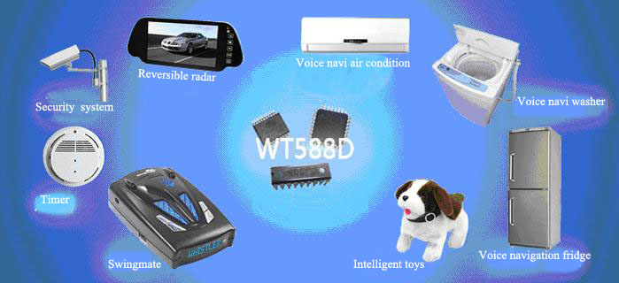

6. WT588D APPLICATION DIAGRAM
BUSY output
USB download

Control interface

WT588D voice chips &

SPI-Flash

Audio output

7. PACKAGE SKETCH
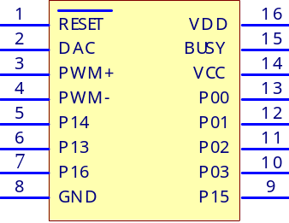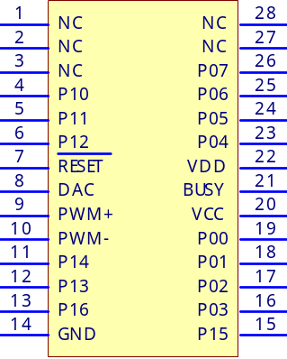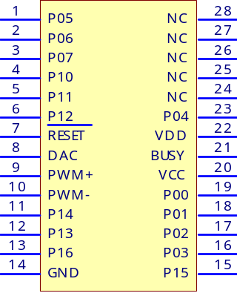
16PIN MODULE 28PIN MODULE (V1.1) 28PIN MODULE (V1.2)

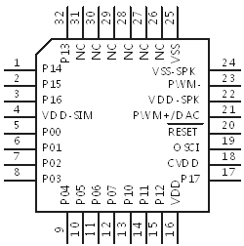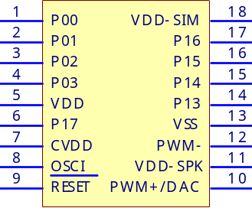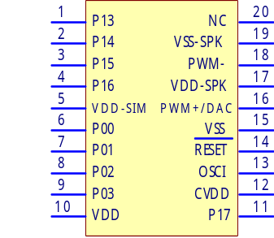
LQPF32 CHIP DIP18 CHIP SSOP20 CHIP

8. PIN DESCRIPTIONS

8.1. WTW-16P PIN’S DESCRIPTION
PIN | MARK | BRIET DESCRIPTION | FUNCTION
1 | RESET | RESET | RESET PIN
2 | PWM+/DAC | PWM+/DAC | PWM+/DAC AUDIO OUTPUT
3 | PWM+/DAC | PWM+/DAC | PWM+/DAC AUDIO OUTPUT
4 | PWM- | PWM- | PWM- AUDIO OUTPUT
5 | P14 | DI | PROGRAMMING INPUT
6 | P13 | DO | PROGRAMMING OUTPUT
7 | P16 | CLK | CLOCK
8 | GND | GND | GROUND
9 | P15 | CS | PROGRAMMING CHIP-SELECT
10 | P03 | K4/CLK/DATA | KEY/THREE-LINE CLOCK/ONE-LINE DATA INPUT
11 | P02 | K3/CS | KEY/THREE-LINE CHIP-SELECT INPUT
12 | P01 | K2/DATA | KEY/THREE-LINE DATA INPUT
13 | P00 | K1 | KEY INPUT
14 | VCC | VCC | MEMORIZER POWER INPUT
15 | BUSY | BUSY | PLAY BUSY SIGNAL OUTPUT
16 | VDD | VDD | DIGITAL POWER INPUT

8.2. WTW-28P (V1.1) PIN’S DESCRIPTION
PIN | MARK | BRIEF DESCRIPTION | FUNCTION
1 | NC | NC | NC
2 | NC | NC | NC
3 | NC | NC | NC
4 | P10 | K9/A7/R1 | KEY/PARALLEL ADDRESS/MATRIX ROW INPUT/THREE-LINE SERIAL EXTENSION ADDRESS
5 | P11 | K10/R2 | KEY/MATRIX ROW INPUT/THREE-LINE SERIAL EXTENSION ADDRESS
6 | P12 | R3 | MATRIX ROW INPUT/THREE-LINE EXTENSION ADDRESS
7 | RESET |  | RESET
8 | PWM+/DAC | PWM+/DAC | PWM+/DAC AUDIO OUTPUT
9 | PWM+/DAC | PWM+/DAC | PWM+/DAC AUDIO OUTPUT
10 | PWM- | PWM- | PWM- AUDIO OUTPUT
11 | P14 | DI | PROGRAMMING DATA INPUT
12 | P13 | DO | PROGRAMMING DATA OUTPUT
13 | P16 | CLK | PROGRAMMING CLOCK
14 | GND | GND | GROUND
15 | P15 | CS | PROGRAMMING CHIP-SELECT
16 | P03 | K4/A2/L3/CLK/DATA | KEY/PARALLEL ADDRESS/MATRIX COLUMN/THEREE-LINE CLOCK/ONE-LINE DATA INPUT
17 | P02 | K3/A1/L2/CS | KEY/PARALLEL ADDRESS/MATRIX COLUMN/THREE-LINE CHIP-SELECT INPUT
18 | P01 | K2/A0/L1/DATA | KEY/PARALLEL ADDRESS/MATRIX COLUMN/THREE-LINE DATA INPUT
19 | P00 | K1/L0/SBT | KEY/MATRIX COLUMN/SBT PARALLEL ADDRESS TRIGGER OUTPUT/THREE-LINE SERIAL EXTENSION OUTPUT ADDRESS
20 | VCC | VCC | ANOLOG POWER INPUT
21 | BUSY | BUSY | PLAY BUSY SIGNAL OUTPUT
22 | VDD | VDD | DIGITAL POWER INPUT
23 | P04 | K5/A3/L4 | KEY/PARALLEL ADDRESS/MATRIX COLUMN INPUT/THREE-LINE SERIAL EXTENSION OUTPUT ADDRESS
24 | P05 | K6/A4/L5 | KEY/PARALLEL ADDRESS/MATRIX COLUMN INPUT/THREE-LINE SERIAL EXTENSION OUTPUT ADDRESS
25 | P06 | K7/A5/L6 | KEY/PARALLEL ADDRESS/MATRIX COLUMN INPUT/THREE-LINE SERIAL EXTENSION OUTPUT ADDRESS
26 | P07 | K8/A6/L7 | KEY/PARALLEL ADDRESS/MATRIX COLUMN INPUT/THREE-LINE SERIAL EXTENSION OUTPUT ADDRESS
27 | NC | NC | NC
28 | NC | NC | NC

8.3. WTW-28P (V1.2) PIN’S DESCRIPTION
PIN | MARK | BRIEF DESCRIPTION | FUNCTION
1 | P05 | K6/A4/L5 | KEY/PARALLEL ADDRESS/MATRIX ROW INPUT/THREE-LINESERIAL EXTENSION ADDRESS
2 | P06 | K7/A5/L6 | KEY/PARALLEL ADDRESS/MATRIX ROW INPUT/THREE-LINE SERIAL EXTENSION ADDRESS
3 | P07 | K8/A6/L7 | KEY/PARALLEL ADDRESS/MATRIX ROW INPUT/THREE-LINE SERIAL EXTENSION ADDRESS
4 | P10 | K9/A7/R1 | KEY/PARALLEL ADDRESS/MATRIX ROW INPUT/THREE-LINE SERIAL EXTENSION ADDRESS
5 | P11 | K10/R2 | KEY/MATRIX ROW INPUT/THREE-LINE SERIAL EXTENSION ADDRESS
6 | P12 | R3 | KEY/MATRIX ROW INPUT/THREE-LINE SERIAL EXTENSION ADDRESS
7 | RESET | RESET | RESET
8 | PWM+/DAC | PWM+/DAC | PWM+/DAC AUDIO OUTPUT
9 | PWM+/DAC | PWM+/DAC | PWM+/DAC AUDIO OUTPUT
10 | PWM- | PWM- | PWM- AUDIO OUTPUT
11 | P14 | DI | PROGRAMMING DATA INPUT
12 | P13 | DO | PROGRAMMING DATA OUTPUT
13 | P16 | CLK | PROGRAMMING CLOCK
14 | GND | GND | GROUND PIN
15 | P15 | CS | PROGRAMMING CHIP-SELECT
16 | P03 | K4/A2/L3/CLK/DATA | KEY/PARALLEL ADDRESS/MATRIX COLUMN/THEREE-LINE CLOCK/ONE-LINE DATA INPUT
17 | P02 | K3/A1/L2/CS | KEY/PARALLEL ADDRESS/MATRIX COLUMN/THREE-LINE CHIP-SELECT INPUT
18 | P01 | K2/A0/L1/DATA | KEY/PARALLEL ADDRESS/MATRIX COLUMN/THREE-LINE CHIP-SELECT INPUT
19 | P00 | K1/L0/SBT | KEY/MATRIX COLUMN/SBT PARALLEL ADDRESS TRIGGER OUTPUT/THREE-LINE SERIAL EXTENSION OUTPUT ADDRESS
20 | VCC | VCC | ANOLOG POWER INPUT
21 | BUSY | BUSY | PLAY BUSY SIGNAL OUTPUT
22 | VDD | VDD | DIGITAL POWER INPUT
23 | P04 | K5/A3/L4 | KEY/PARALLEL ADDRESS/MATRIX COLUMN INPUT/THREE-LINE SERIAL EXTENSION OUTPUT ADDRESS
24 | NC | NC | NC
25 | NC | NC | NC
26 | NC | NC | NC
27 | NC | NC | NC
28 | NC | NC | NC

8.4. WT588D-32L PACKAGE PIN’S DESCRIPTION
PIN | MARK | BRIEF DESCRIPTION | FUNCTION
1 | P14 | DI | MEMORIZER DATA COMMUNICATIONS INPUT
2 | P15 | DO | MEMORIZER COMMUNICATIONS CHIP-SELECT
3 | P16 | CS | MEMORIZER COMMUNICATIONS CLOCK
4 | VDD-SIM | CLK | SERIAL POWER INPUT
5 | P00 | VDD-SIM | KEY/MATRIX COLUMN/SBT PARALLEL ADDRESS TRIGGER OUTPUT/THREE-LINE SERIAL EXTENSION OUTPUT ADDRESS
6 | P01 | K2/A0/L1/DATA | KEY/PARALLEL ADDRESS/MATRIX COLUMN/THREE-LINE DATA INPUT
7 | P02 | K3/A1/L2/CS | KEY/PARALLEL ADDRESS/MATRIX COLUMN/THREE-LINE CHIP-SELECT INPUT
8 | P03 | K4/A2/L3/CLK/DATA | KEY/PARALLEL ADDRESS/MATRIX COLUMN/THREE-LINE CLOCK/ONE-LINE DATA INPUT
9 | P04 | K5/A3/L4 | KEY/PARALLEL ADDRESS/MATRIX COLUMN INPUT/THREE-LINE SERIAL EXTENSION OUTPUT ADDRESS
10 | P05 | K6/A4/L5 | KEY/PARALLEL ADDRESS/MATRIX COLUMN INPUT/THREE-LINE SERIAL EXTENSION OUTPUT ADDRESS
11 | P06 | K7/A5/L6 | KEY/PARALLEL ADDRESS/MATRIX COLUMN INPUT/THREE-LINE SERIAL EXTENSION OUTPUT ADDRESS
12 | P07 | K8/A6/L7 | KEY/PARALLEL ADDRESS/MATRIX COLUMN INPUT/THREE-LINE SERIAL EXTENSION OUTPUT ADDRESS
13 | P10 | K9/A7/R1 | KEY/PARALLEL ADDRESS/MATRIX COLUMN INPUT/THREE-LINE SERIAL EXTENSION OUTPUT ADDRESS
14 | P11 | K10/R2 | KEY/MATRIX ROW INPUT/THREE-LINE SERIAL EXTENSION OUTPUT ADDRESS
15 | P12 | R3 | MATRIX ROW INPUT/THREE-LINE SERIAL EXTENSION OUTPUT ADDRESS
16 | VDD | VDD | CHIP POWER INPUT
17 | P17 | BUSY | PLAY BUSY SIGNAL OUTPUT
18 | CVDD | CVDD | VDD POWER VOLTAGE ADJUSTMENT
19 | OSCI | OSCI | CRYSTAL OSCILLATOR INPUT
20 | RESET | RESET | RESET
21 | PWM+/DAC | PWM+/DAC | PWM+/DAC AUDIO OUTPUT
22 | VDD-SPK | VDD-SPK | AUDIO POWER INPUT
23 | PWM- | PWM- | PWM- AUDIO OUTPUT
24 | VSS-SPK | VSS-SPK | AUDIO POWER GROUND
25 | VSS | VSS | GROUND
26 | NC | NC | NC
27 | NC | NC | NC
28 | NC | NC | NC
29 | NC | NC | NC
30 | NC | NC | NC
31 | NC | NC | NC
32 | P13 | DO | MEMORIZER DATA COMMUNICATIONS OUTPUT

8.5. WT588D-18P PACKAGE PIN’S DESCRIPTION
PIN | MARK | DESCRIPTION | FUNCTION
1 | P00 | K1 | KEY
2 | P01 | K2/DATA | KEY/ THREE-LINE DATA INPUT
3 | P02 | K3/CS | KEY/ THREE-LINE CS INPUT
4 | P03 | K4/A2/CLK/DATA | KEY/PARALLEL ADDRESS/THREE-LINE CLOCK/ONE-LINE DATA INPUT
5 | VDD | VDD | POWER IN
6 | P17 | BUSY | BUSY OUT
7 | CVDD | CVDD | VDD POWER ADJUSTMENT
8 | OSCI | OSCI | CRYSTAL OSCILLAOR INPUT
9 | RESET | RESET | RESET, KEEP LOW LEVEL>5MS
10 | PWM+/DAC | PWM+/DAC | PWM+/DAC AUDIO OUTPUT
11 | VDD-SPK | VDD-SPK | AUDIO POWER INPUT
12 | PMW- | PWM- | PWM- AUDIO OUTPUT
13 | VSS | VSS | GROUND
14 | P13 | DO | SPI-FLASH COMMUNICATION DATA OUTPUT
15 | P14 | DI | SPI-FLASH COMMUNICATION DATA INPUT
16 | P15 | CS | SPI-FLASH COMMUNICATION CS
17 | P16 | CLK | SPI-FLASH COMMUNICATION CLOCK
18 | VDD-SIM | VDD-SIM | SERIALINTERFACE POWER MANAGEMENT

8.6. WT588D-20SS PACKAGE PIN’S DESCRIPTION
PIN | MARK | DESCRIPTION | FUNCTION
1 | P13 | DO | SPI-FLASH DATA COMMUNICATIONS OUTPUT
2 | P14 | DI | SPI-FLASH DATA COMMUNICATIONS INPUT
3 | P15 | CS | SPI-FLASH COMMUNICATIONS CHIP-SELECT
4 | P16 | CLK | SPI-FLASH COMMUNICATIONS CLOCK
5 | VDD-SIM | VDD-SIM | SERIAL INTERFACE POWER MANAGEMENT
6 | P00 | K1 | KEY
7 | P01 | K2/DATA | KEY /THREE-LINE DATA INPUT
8 | P02 | K3/CS | KEY /THREE-LINE CHIP-SELECT INPUT
9 | P03 | K4/ CLK/DATA | KEY /THREE-LINE CLOCK/ONE-LINE DATA INPUT
10 | VDD | VDD | POWER INPUT
11 | P17 | BUSY | PLAY BUSY SIGNAL OUTPUT
12 | CVDD | CVDD | VDD POWER ADJUSTMENT
13 | OSCI | OSCI | CRYSTAL OSCILLATOR INPUT
14 | RESET | RESET | RESET, KEEP LOW LEVEL>5MS
15 | VSS | VSS | GROUND
16 | PWM+/DAC | PWM+/DAC | PWM+/DAC AUDIO OUTPUT
17 | VDD-SPK | VDD-SPK | AUDIO POWER INPUT
18 | PWM- | PWM- | PWM- AUDIO INPUT
19 | VSS-SPK | VSS-SPK | AUDIO POWER GROUND
20 | NC | NC | NC

9. PIN’S DETAILED DESCRIPTION
THE USE OF K1－K10
K1－K10 defined as I/O port of key trigger ,corresponding I/O port P00－p07|、p10 and P11. Switch I/O port level by K1 －k10 or input edge to I/O port, trigger to play the voice. Trigger mode of Key K0－k9 can be setted as edge retrigger, edge no retrigger, level unloop, level loop, , level hold loop, prev unloop, next unloop, prev loop, next loop, no function, pause, stop, vol+, vol- and on/off 15 kinds of trigger mode.

KEY MODE: P00→K1 P01→K2 P02→K3 P03→K4 P04→K5
P05→K6 P06→K7 P07→K8 P10→K9 P11→K10

ONE-LINE SERIAL INTERFACE MODE: P00→K1 P04→K5 P07→K8
P01→K2 P05→K6 P10→K9
P02→K3 P06→K7 P11→K10
THE USE OF R1-R3、L0－L7
In the key control mode of 3x8 matrix, I/O port defined as R－R3、L0－L7，R1－R3 as matrix row input , L0－L7 as matrix column input. A phrase can be triggered and play when short circuit R and L. In this control mode, all keys trigger mode were defined as EDGE RETRIGGER. The details please find 12.3
The use of SBT and A0-A7
In the parallel control mode, I/O port P00-P07、P10 defined as SBT, A0-A7. SBT is audition feet, A0-A7 are address, from low to high. I/O port details please find 12.4

10. ELECTRONIC PARAMETERS
（VDD − VSS = 4.5V, TA = 25°C，without load）
PARAMETER | MARK | ENVIRONMENT CONDITION | MIN VALUE | TYPICAL VALUE | MAX | UNITS
OPERATING VOLTAGE | V_{DD} | F_{sys}=8MHz | 2.8 |  | 5.5 | V
OPERATING CURRENT | I_{OP1} | WITHOUT LOAD | - | 4.5 | 5.5 | mA
SUSPEND CURRENT | I_{DD2} | WITHOUT LOAD | - | 1 | 3 | uA
HIBERNATE MODE | I_{OP2} | WITHOUT LOAD | - | 650 |  | uA
LOW VOLTAGE INPUT | V_{IL} | ALL OF PINS INPUT | V_{SS} | - | 0.3V_{DD} | V
HIGH VOLTAGE INPUT | V_{IH} | ALL OF PINS INPUT | 0.7V_{DD} | - | V_{DD} | V
CURRENT INPUT  BP1、BP2、RESET | I_{IN1} | V_{IN}=0V  PULL RESISTANCE=500KΩ | -5 | -9 | -14 | uA
CURRENT INPUT  BP1、BP2、RESET | I_{IN2} | V_{IN}=0V  PULL RESISTANCE=150KΩ | -15 | -30 | -45 | uA
CURRENT INPUT（BP0） | I_{OL} | VDD=3V，VOUT=0.4V | 8 | 12 | - | mA
CURRENT INPUT（BP0） | I_{OH} | VDD=3V，VOUT=2.6V | -4 | -6 | - | mA
CURRENT INPUT（BP0） | I_{OL} | VDD=4.5V，VOUT=1.0V | - | 25 | - | mA
CURRENT INPUT（BP0） | I_{OH} | VDD=4.5V，VOUT=2.6V | - | -12 | - | mA
CURRENT OUTPUT（BP1） | I_{OL} | VDD=3V，VOUT=0.4V | 4 | 10 | - | mA
CURRENT OUTPUT（BP1） | I_{OH} | VDD=3V，VOUT=2.6V | -4 | -6 | - | mA
CURRENT OUTPUT  PWM+/PWM- | I_{OL1} | RL=8Ω  【PWM+】--【RL】--【PWM-】 | +200 | - | - | mA
CURRENT OUTPUT  PWM+/PWM- | I_{OH1} | RL=8Ω  【PWM+】--【RL】--【PWM-】 | -200 | - | - | mA
DAC MAX CURRENT | I_{DAC} | RL=100Ω | -2.4  -4.0 | -3.0  -5.0 | -3.6  -6.0 | mA
PULL RESISTANCE TASTING | R_{PL} |  | 75 | 150 | 225

11. ENVIRONMENTAL LIMITED PARAMETER
PARAMETER | MARK | CONDITION | RATED VALUE | UNIT
POWER | VDD — VSS | - | -0.3～+7.0 | V
INPUT VOLTAGE | VIN | ALL INPUT | VSS-0.3～VDD+0.3 | V
STORE TEMPERATURE | TSTG | - | -55～+150 | °C
USING TEMPERATURE | TOPR | - | -40～+85 | °C

12. CONTROL MODE

12.1. MP3 MODE
In the mp3 mode, default function of 6 I/O port
I/O | P00 | P01 | P02 | P03 | P04 | P05
FUNCTION | STOP | PLAY/PAUSE | NEXT | PREVIOUS | VOL+ | VOL-

12.2. KEY CONTROL MODE
Defined pin can trigger a function of the chip, each pin’s trigger mode can be set solely. Anti-shake time of the key control mode is 10ms. In this mode, include edge retrigger, edge irretrigger, level unloop, level loop, level hold loop, prev unloop, next unloop, prev loop, next loop, no function, pause, stop, vol+, vol- and on/off 15 kinds of trigger mode. Detailed diagram as follows:

12.2.1. EDGE RETRIGGER
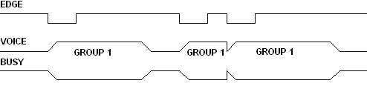
Remark: Negative edge trigger. When the I/O port test falling edge (for example short circuit of I/O and GND at 10ms), the voice will be triggered and playing. If another falling edge is tested, the voice will be interrupted and replay.

12.2.2. EDGE IRRETRIGGER
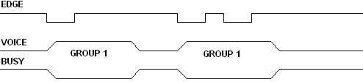
Remark: Negative edge trigger. When falling edge was tested by I/O port (for example short circuit of I/O and GND at 10ms), the voice can be triggered and playing. During the voice are playing, the falling edge was tested again, the voice will not be interrupted until the voice is over.

12.2.3. LEVEL LOOP
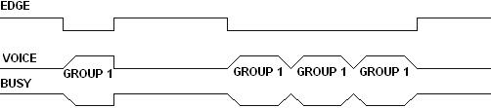
Remark: Triggered by low level, mean press the button. It will play the voice when you press the button until you stop playing. If you keep to press all the time, it will keep playing, loop.

12.2.4. LEVEL UNLOOP
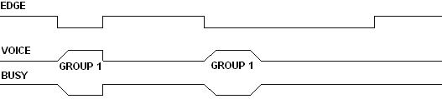
Remark: Triggered by low level. Mean press the button. It will play the voice when you press the button until you stop playing. But it just play one time, no loop, whatever you keep to press the button.

12.2.5. LEVEL HOLD LOOP
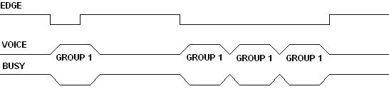
Remark: Negative edge/level trigger. When the I/O at low level(for example short circuit of I/O and GND at 10ms), it will play the voice one time, during the playing even turn to high level it will not stop until the first play is over. If still keep low level, it will keep playing again and again, loop.

12.2.6. ON/OFF
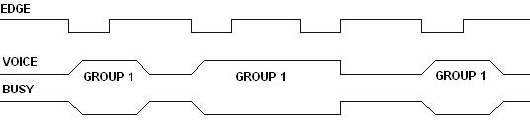
Remark: Negative edge trigger. Press the button it will play voice, and press again, the voice will stop.

12.2.7. NEXT UNLOOP
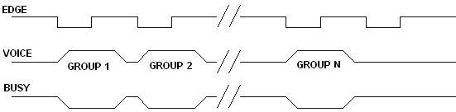
Remark: Negative edge trigger. Press the button it will play the next song, press again, plays the next, etc. It will not to play song if the last song is play over.

12.2.8. PREV UNLOOP
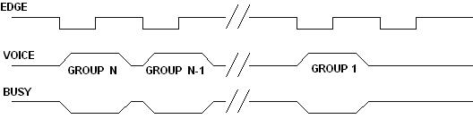
Remark: Negative edge trigger. Press the button it will play the previous song, press again, plays the pre-, etc. It will not to play song if the first song is play over.

12.2.9. NEXT LOOP
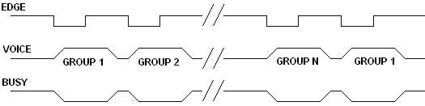
Remark: Negative edge trigger. Press the button it will play the next song, press again, plays the next, etc. It will play the first song if the last song is play over.

12.2.10. PREV LOOP
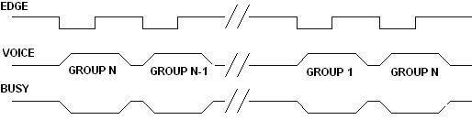
Remark: Negative edge trigger. Press the button it will play the previous song, press again, plays the pre-, etc. It will play the last song if the first song is play over.

12.2.11. PAUSE
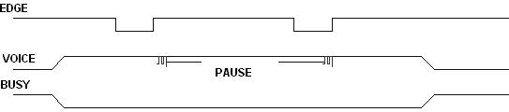

Remark: Negative edge trigger. Press the button it will pause to play the current song, then press the button again, it will go to play the song.

12.2.12. STOP
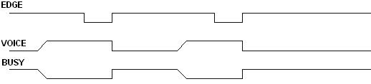
Remark: Negative edge trigger. Press the “stop” button it will pause to play the current song, even if press the button which control to play the song, is invalid.

12.3. 3X8 MATRIX KEY CONTROL MODE
In this mode, all keys default as edge retrigger, can trigger 24 groups voice directly, voice addresses can be defined.
I/O | P00 | P01 | P02 | P03 | P04 | P05 | P06 | P07
P10 | Key1 | Key2 | Key3 | Key4 | Key5 | Key6 | Key7 | Key8
P11 | Key9 | Key10 | Key11 | Key12 | Key13 | Key14 | Key15 | Key16
P12 | Key17 | Key18 | Key19 | Key20 | Key21 | Key22 | Key23 | Key24

12.4. PARALLEL CONTROL MODE
In this mode, P00 defined as SBT trigger feet, playing voice by changing the address “An”. Pins’ definition as follows:
PACKAGES | PINS
PACKAGES | P00 | P01 | P02 | P03 | P04 | P05 | P06 | P07 | P10
WTW500-28 | SBT | A0 | A1 | A2 | A3 | A4 | A5 | A6 | A7
WT588D-32L | SBT | A0 | A1 | A2 | A3 | A4 | A5 | A6 | A7

12.4.1. VOICE ADDRESSES CORRESPONDING LIST
GROUP N (VOICE) | ADDRESS FEET
GROUP N (VOICE) | A7 | A6 | A5 | A4 | A3 | A2 | A1 | A0
GROUP0 | 0 | 0 | 0 | 0 | 0 | 0 | 0 | 0
GROUP1 | 0 | 0 | 0 | 0 | 0 | 0 | 0 | 1
GROUP2 | 0 | 0 | 0 | 0 | 0 | 0 | 1 | 0
…… | …… | …… | …… | …… | …… | …… | …… | ……
GROUP217 | 1 | 1 | 0 | 1 | 1 | 0 | 0 | 1
GROUP218 | 1 | 1 | 0 | 1 | 1 | 0 | 1 | 0
GROUP219 | 1 | 1 | 0 | 1 | 1 | 0 | 1 | 1

12.4.2. CONTROL TIMING DIAGRAM
Set the addresses to I/O(P01～P10) by MCU, then play the speech by trigger the SBT feet , the trigger mode can be defined as edge retrigger, edge on retrigger, on/off, prev unloop, next unloop, prev loop, next loop, level unloop, level loop, level hold loop, pause.
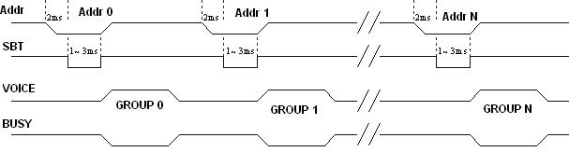
10MS
10MS
Send addresses, then send SBT trigger playing voice after 2ms, and signal maintain 10ms.

12.5. ONE-LINE SERIES INTERFACE CONTROL MODE
In this mode, can achieve functions: ON / OFF, Volume adjustable, Trigger playing voice, etc. The keys from P00-P10 can choose any trigger mode. Note: In this mode, the voice chip without sleep state, after stopping play, the current is about 5mA, please take care when use battery supply.

12.5.1. ASSIGNMENT OF I/O
PACKAGES | I/O PORTS OF VOCIE CHIPS OR MODULES
PACKAGES | P00 | P01 | P02 | P03 | P04 | P05 | P06 | P07 | P10 | P11
WT588D-18P | K1 | K2 | K3 | DATA | --- | --- | --- | --- | --- | ---
WT588D-20SS | K1 | K2 | K3 | DATA | --- | --- | --- | --- | --- | ---
WT588D-32L | K1 | K2 | K3 | DATA | K5 | K6 | K7 | K8 | K9 | K10
WTW500-16 | K1 | K2 | K3 | DATA | --- | --- | --- | --- | --- | ---
WTW500-28 | K1 | K2 | K3 | DATA | K5 | K6 | K7 | K8 | K9 | K10

12.5.2. COMMAND AND CODE
CODE | FUNCTIONS | DESCRIPTIONS
E0H～E7H | VOLUME ADJUSTMENT | DURING THE PLAYING OR STANDBY,THERE ARE 8 LEVEL VOLUME CAN BE ADJUSTED BY SENDING COMMAND, E0H IS MINIMUM, E7H IS MAXIMUM
F2H | LOOP PLAY | DURING THE PLAY, SPEECH IN CURRENT ADDRESS CAN BE LOOP PALYED BY SENDING COMMAND
FEH | STOP TO PLAY | STOP PLAYING

12.5.3. THE RELATIONSHIP BETWEEN SPEECH AND ADDRESS
DATA(HEX) | FUNCTION
00H | PLAY VOICE OF GROUP 0
01H | PLAY VOICE OF GROUP 1
02H | PLAY VOICE OF GROUP 2
….. | …….
D9H | PLAY VOICE OF GROUP 217
DAH | PLAY VOICE OF GROUP 218
DBH | PLAY VOICE OF GROUP 219

12.5.4. CONTROL TIMING DIAGRAM
One Line Serial mode only need one line, the data bit is depend on the duty cycle. Pull low RESET signal 5ms, wait not less than 17ms in high level, and pull low data signal 5ms before sent out data. The data bit is 0 if duty cycle is 1/3 , and is 1 if duty cycle is 2/3.
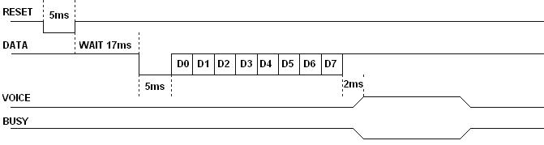
Remark: Reset before sending the data, unless work in interferential environment. DATA is for one-line data communication. Pull low 5ms after reset , for waking up the chip, low level before high level. 2mS after data sent out, BUSY output will be acted.

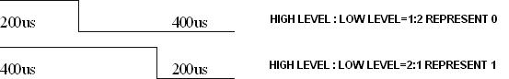

12.2.5. ONE LINE SERIAL CONTROL DIAGRAM SAMPLE
FOR EXAMPLE, IN THE ONE-LINE CONTROL MODE, THE TIMING OF SENDING DATA 9CH
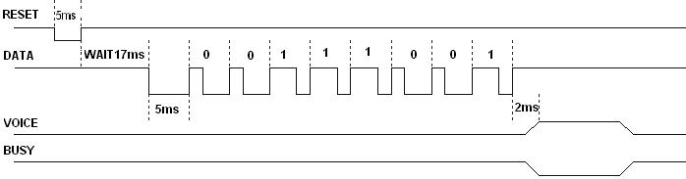

12.5.5. PROGRAM EXAMPLE
MICROCONTROLLER: PIC16F54, CLOCK SPEED:4MHz
Send oneline(unsigned char addr)
{
rst=0; /*reset the chip */
delay1ms(2); /*delay 1ms to 5ms */
rst=1;
delay1ms(6); /*delay 6ms */
sda=0;
delay1ms(5); /* delay 5ms */
for(i=0;i<8;i++)
{ sda=1;
if(addr & 1)
{ delay1us(600); /* 600us */
sda=0;
delay1us(300); } /* 300us */
else {
delay1us(300); /* 300us */
sda=0;
delay1us(600); } /* 600us */
addr>>=1; }
sda=1; }

12.6.THREE-LINE SERIAL CONTROL MODE
This mode consist of three communication line, they are CS,DATA,SCK, timing imitate the standard SPI means of communication.

12.6.1.ASSIGNMENT OF I/O
PACKAGE | I/O
PACKAGE | P00 | P01 | P02 | P03 | P04 | P05 | P06 | P07 | P10 | P11
SOP28 | -- | DATA | CS | SCK | -- | -- | -- | -- | -- | --
SSOP28 | -- | DATA | CS | SCK | -- | -- | -- | -- | -- | --

12.6.2. SPEECH AND COMMAND
CODE | FUNCTION | DESCRIPTION
E0H-E7H | VOLUME ADJUSTMENT | DURING THE PLAYING OR STANDBY,THERE ARE 8 LEVEL VOLUME CAN BE ADJUSTED BY SENDING COMMAND, E0H IS MINIMUM, E7H IS MAXIMUM
F2H | LOOP PLAY | DURING THE PLAY, SPEECH IN CURRENT ADDRESS CAN BE LOOP PALYED BY SENDING COMMAND
FEH | STOP TO PALY | THE COMMAND OF STOP PLAYING
F5H | ENTRY I/O EXTENSION OUTPUT | IN THE COMMOND THREE-LINE SERIAL MODE,ENTRY I/O EXTENSION OUTPUT STATE BY SENDING COMMAND
F6H | EXIT I/O EXTENSION OUTPUT | IN THE I/O EXTENSION OUTPUT STATE, ENTRY COMMOND THREE-LINE SERIAL MODE BY SENDING THIS COMMAND

12.6.3.THE RELATIONSHIP BETWEEN SPEECH AND ADDRESS
DATA(HEX) | FUNCTION
00H | PLAY THE SPEECH OF 0
01H | PLAY THE SPEECH OF 1
02H | PLAY THE SPEECH OF 2
….. | ……….
D9H | PLAY THE SPEECH OF 217
DAH | PLAY THE SPEECH OF 218
DBH | PLAY THE SPEECH OF 219

12.6.4. THREE-LINE SERIAL CONTROL I/O EXTENSION OUTPUT
In the three-line serial control mode, entry three-line serial I/O extension output by sending data F5H, sending the binary data and make the related I/O to output high level ,sequentially, control the periphery circuit . Send data F6H,will exit this mode, entry commond three-line serial control mode.
GROUD N | I/O
GROUD N | P12 | P11 | P10 | P07 | P06 | P05 | P04 | P00
GROUP 0 | 0 | 0 | 0 | 0 | 0 | 0 | 0 | 0
GROUP 1 | 0 | 0 | 0 | 0 | 0 | 0 | 0 | 1
GROUP 2 | 0 | 0 | 0 | 0 | 0 | 0 | 1 | 0
………… | ………… | ………… | ………… | ………… | ………… | ………… | ………… | …………
GROUP217 | 1 | 1 | 0 | 1 | 1 | 0 | 0 | 1
GROUP218 | 1 | 1 | 0 | 1 | 1 | 0 | 1 | 0
GROUP219 | 1 | 1 | 0 | 1 | 1 | 0 | 1 | 1
The data in the form, 0 represents low level output, 1 represents high level output. Switch to I/O extension output from three-line serial control mode, the last trigger mode of three-line serial control mode be kept. If setted loop play, the last triggered speech will keep loop playing until switch back to three-line serial mode, and change trigger mode. Switch I/O extension mode to three-line serial control mode, the last I/o extension function also be kept, in the I/O extension output,P00 setted as high level output, after switch to three-line serial control mode, P00 still keep high level output until switch back to I/O extension output and change settings.
I/O extension output can extend 8 I/O, applicate in the situation of poor I/O.

12.6.5. THREE-LINE SERIAL CONTROL TIMING
Three-line serial control mode consist of CS, SCK , DATA, timing imitate standard SPI communication mode, pull low 1ms-5ms before reset signal send out code. During working , RESET pin should keep high when chip is working. CS should keep low 2ms-10ms to wake up the chip,data LSB first,data clock in chip in rising edge. clock cycle is 40us-2ms. BUSY signal will active in 2ms after data transmit success. Low first ,then high ,when transmit data . Timing diagram as follow:
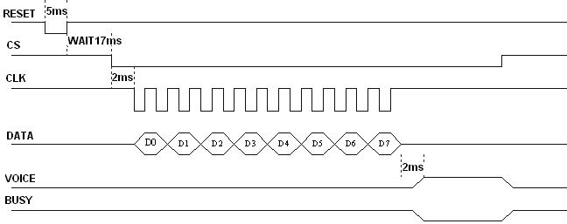

12.6.6. PROGRAM EXSAMPLE
(Microcotroller PIC16F54,system speed 4MHz)
Send threelines(unsigned char addr)
｛rst=0;
delay1ms(5);rst=1;
delay1ms(17);
cs=0;
delay1ms(2);
for(i=0;i<8;i++)
｛ scl=0;
if(addr & 1)sda=1;
else sda=0;
addr>>=1;
delay1us(30);
scl=1;
delay1us(30); ｝
cs=1;｝

13. CONTROL TIMING

13.1.CONTROL TIMING DIAGRAM
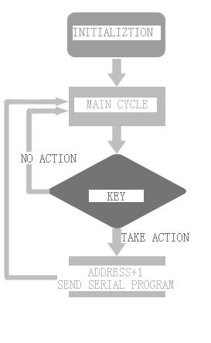

13.2. ONE-LINE SERIAL CONTROL PROGRAMMING
This program only for one-line serial control mode application circuit in “WT588D CHIP&MODULE DETAILED INFORMATION”.
ORG 0000H
KEY EQU P1.1 ;key pin
RST EQU P1.4 ;reset pin
SDA EQU P3.0 ;data pin
DAIFAZHI EQU 50H ;send code value temp
MOV DAIFAZHI,#0H;intial send value 0
MOV R5,#8 ;loop eight times

MAIN:
JB KEY,MAIN
MOV R6,#20 ;delay 20MS
LCALL DELAY1MS
JB KEY,MAIN ;key press debounce
JNB KEY,$ ;wait key pressed release
LCALL one_line ;call one line program
INC DAIFAZHI ;send value add 1
MOV A,DAIFAZHI
CJNE A,#210,XX2 ;
XX2: JC XX3
MOV DAIFAZHI,#0H
XX3: LJMP MAIN

one_line: ;////one line send code subprogram
CLR RST
MOV R6,#5 ;delay5MS
LCALL DELAY1MS
SETB RST
MOV R6,#17 ;delay17MS
LCALL DELAY1MS
CLR SDA
MOV R6,#5 ;delay5MS
LCALL DELAY1MS
MOV A,DAIFAZHI
LOOP: SETB SDA
RRC A
JNC DIDIANPIN ;high level high:low=2:1
LCALL DELAY200US
LCALL DELAY200US
CLR SDA
LCALL DELAY200US
LJMP LOOP1
DIDIANPIN: ;low level low:high=1:2
LCALL DELAY200US
CLR SDA
LCALL DELAY200US
LCALL DELAY200US
LOOP1: DJNZ R5,LOOP
MOV R5,#08H
SETB SDA
RET
DELAY200US: MOV R6,#100 ;delay 400US subprogram
DJNZ R6,$
RET
DELAY1MS: ;delay 1mssub program, change r6 value can change delay time
L1: MOV R7,#248
DJNZ R7,$
DJNZ R6,L1
RET
END

13.3. ONE-LINE SERIAL CONTROL “C” PROGRAMMING LANGUAGE
This program only for one-line serial control mode application circuit in “WT588D CHIP&MODULE DETAILED INFORMATION”.
#include <at89x2051.H>
sbit KEY=P1^1; /*P1_1 is P1 bit2*/
sbit RST=P1^4^; /*P1_4 is bit3*/
sbit SDA=P3^0; /*P3_0 is bit4*/
void delay1ms(unsigned char count) //1MS delay subprogram
{
unsigned char i,j,k;
for(k=count;k>0;k--)
for(i=2;i>0;i--)
for(j=248;j>0;j--);
}

void delay100us(unsigned char count) //100US delay subprogram
{ unsigned char i;
unsigned char j;
for(i=count;i>0;i--)
for(j=50;j>0;j--);
}

Send_oneline(unsigned char addr)
{
unsigned char i;
RST=0;
delay1ms(5); /*wait reset delay 5MS*/
RST=1;
delay1ms(17); /* delay 17ms */
SDA=0;
delay1ms(5); /* delay 5ms */
for(i=0;i<8;i++)
{SDA=1;
if(addr & 1)
{delay100us(4); /* 400us */
SDA=0;
delay100us(2); /* 200us */
}
else {
delay100us(2); /* 200us */
SDA=0;
delay100us(4); /* 400us */
}
addr>>=1; }
SDA=1;
}

main()
{unsigned char FD=0;
P3=0XFF;
while(1)
{
if(KEY==0)
{
delay1ms(10);
if(KEY==0) //press key P1.1 increase by decrease key value
{
Send_oneline(FD);
FD++;
if(FD==210) //one line control mode, control 210 sectors at best
{
FD=0;
}
while(KEY==0); //wait key pressed release, debounce time
}
}
}
}

13.4. THREE-LINE SERIAL COTROL PROGRAMMING
This program only for three-line serial control mode application circuit in “WT588D CHIP&MODULE DETAILED INFORMATION”.
ORG 0000H
KEY EQU P1.1 ;key pin
RST EQU P1.4 ;reset pin
CS EQU P3.1 ;CS trigger pin
SCL EQU P3.2 ;clock pin
SDA EQU P3.0 ;data pin
DAIFAZHI EQU 50H ;send value temp address
MOV DAIFAZHI,#0H;intinal send value 0
MOV R5,#8 ;loop eight times

MAIN:
JB KEY,MAIN
MOV R6,#20 ;delay 20MS
LCALL DELAY1MS
JB KEY,MAIN ;key debounce
JNB KEY,$ ;wait key pressed release
LCALL THREE_LINE;call three line subprogram
INC DAIFAZHI ;send value add 1
MOV A,DAIFAZHI
CJNE A,#220,XX2 ;judge the sector address if at max
XX2: JC XX3
MOV DAIFAZHI,#0H
XX3: LJMP MAIN

THREE_LINE: ;////three line subprogram
CLR RST
MOV R6,#5 ;delay 5MS
LCALL DELAY1MS
SETB RST
MOV R6,#17 ;delay 17MS
LCALL DELAY1MS
CLR CS
MOV R6,#2 ;delay 2MS
LCALL DELAY1MS
MOV A,DAIFAZHI
LOOP:
CLR SCL
RRC A
MOV SDA,C
LCALL DELAY50US
SETB SCL
LCALL DELAY50US
DJNZ R5,LOOP
MOV R5,#08H
SETB CS
RET
DELAY50US: MOV R6,#25 ;delay 50US subprogram
DJNZ R6,$
RET
DELAY1MS: ;delay 1ms,change r6 value can change delay time
L1: MOV R7,#248
DJNZ R7,$
DJNZ R6,L1
RET
END

13.5. THREE-LINE SERIAL CONTROL “C” PROGRAMMING LANGUAGE
This program only for three-line serial control mode application circuit in “WT588D CHIP&MODULE DETAILED INFORMATION”.
#include <at89x51.H>
sbit KEY=P1^1; /*P1_1 P1 bit2*/
sbit RST=P1^4; /*P1_4 P1 bit3*/
sbit CS=P3^1; /*P3_1 P1 bit4 */
sbit SCL=P3^2; /*P3_2 P3 bit3*/
sbit SDA=P3^0; /*P3_0 P3 bi1*/
//sbit DENG=P3^7; /*P3_5 P3 bit6*/
void delay1ms(unsigned char count) //1MS delay subprogram
{
unsigned char i,j,k;
for(k=count;k>0;k--)
for(i=2;i>0;i--)
for(j=248;j>0;j--);
}

void delay100us(void) //100US delay subprogram
{
unsigned char j;
for(j=50;j>0;j--);
}

Send_threelines(unsigned char addr) //three line send code subprogram
{unsigned char i;
RST=0;
delay1ms(5);
RST=1;
delay1ms(17); /* 17ms*/
CS=0;
delay1ms(2);
for(i=0;i<8;i++)
{SCL=0;
if(addr & 1)SDA=1;
else SDA=0;
addr>>=1;
delay100us(); /* 100us */
SCL=1;
delay100us();
}
CS=1;
}

main()
{unsigned char FD=0;
P3=0XFF;
while(1)
{
if(KEY==0)
{
delay1ms(20);
if(KEY==0) // press key P1.1 increase by decrease key value
{
Send_threelines(FD);
FD++;
if(FD==220// three line control mode, control 220 sectors at best {
FD=0;
}
while(KEY==0); //wait key pressed release
}
}
}
}

